**Cross region and same region replication:**

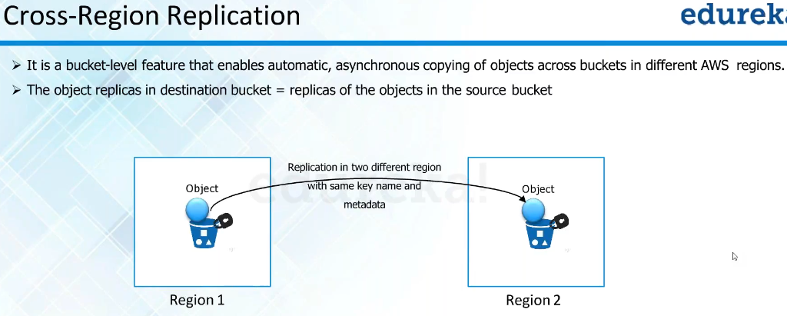

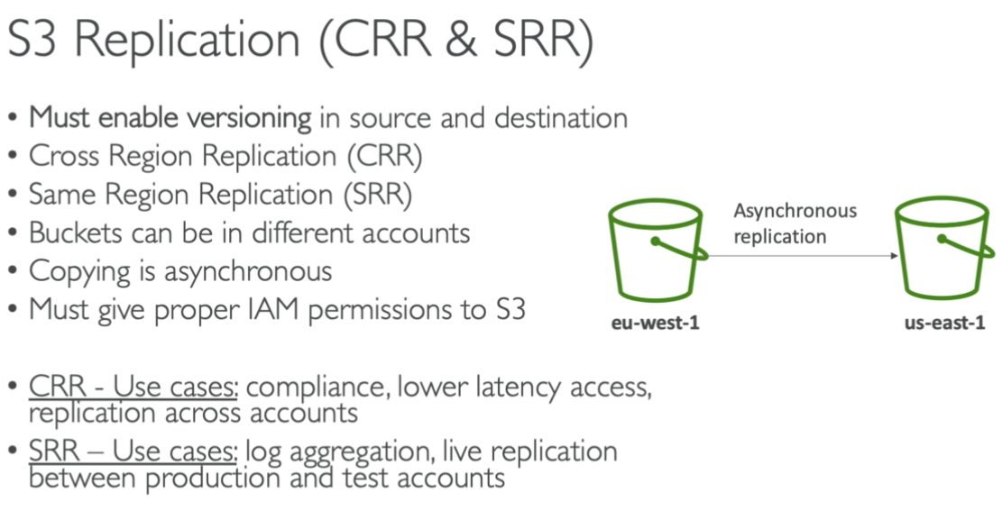

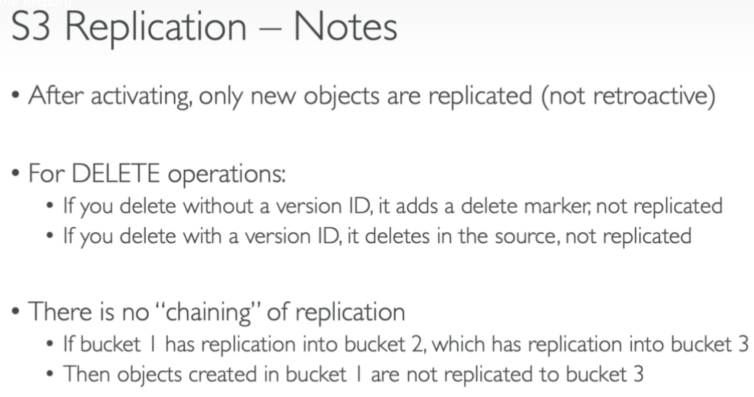

**Hands on:**

* First, enable the versioning on both the buckets.
* Now, go to replication option under management option of a bucket. Click on “Add rule” option there.

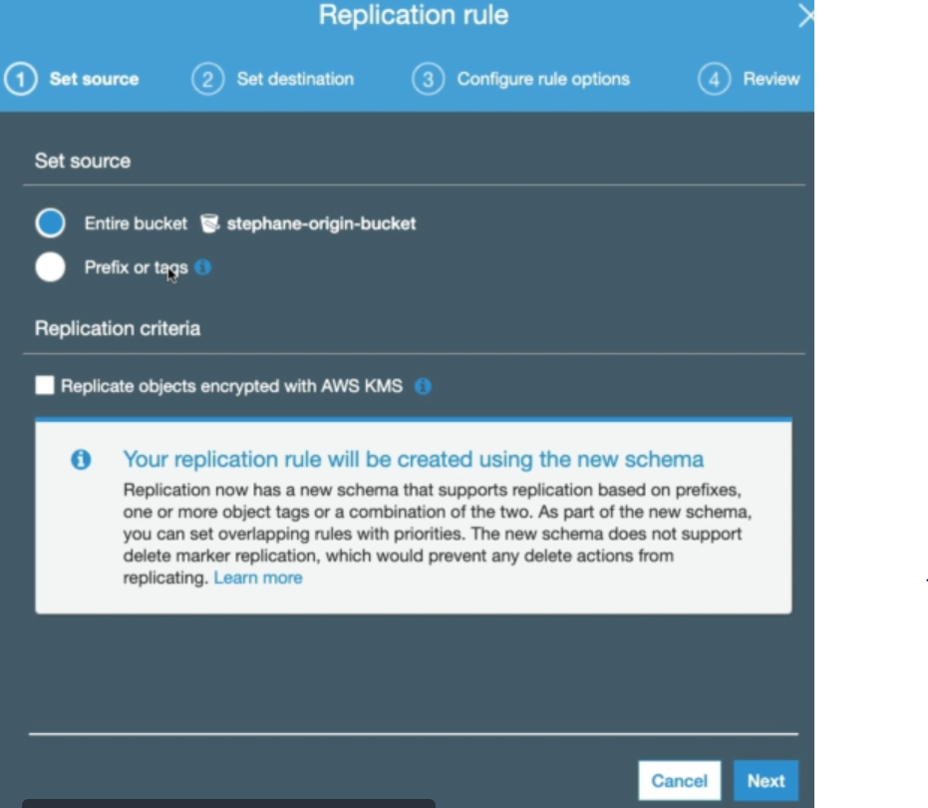

* We can select the entire bucket or some objects with some prefix or tags
* We can also select the option if we want to replicate the objects encrypted with AWS KMS.

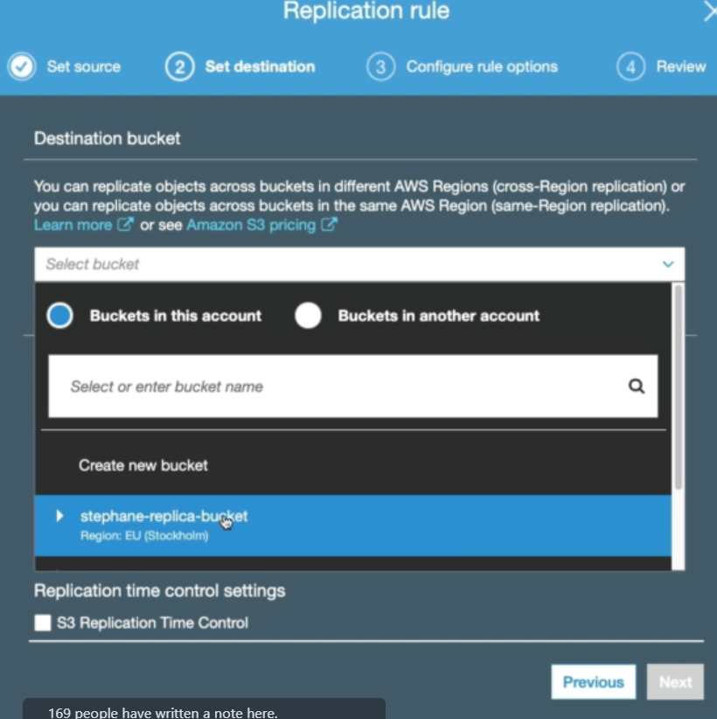

* We need to select the bucket with which the replication needs to be enabled
* And automatically, it would show the bucket of same region and other regions as well.
* We can also select the option to list the buckets from another account as above.

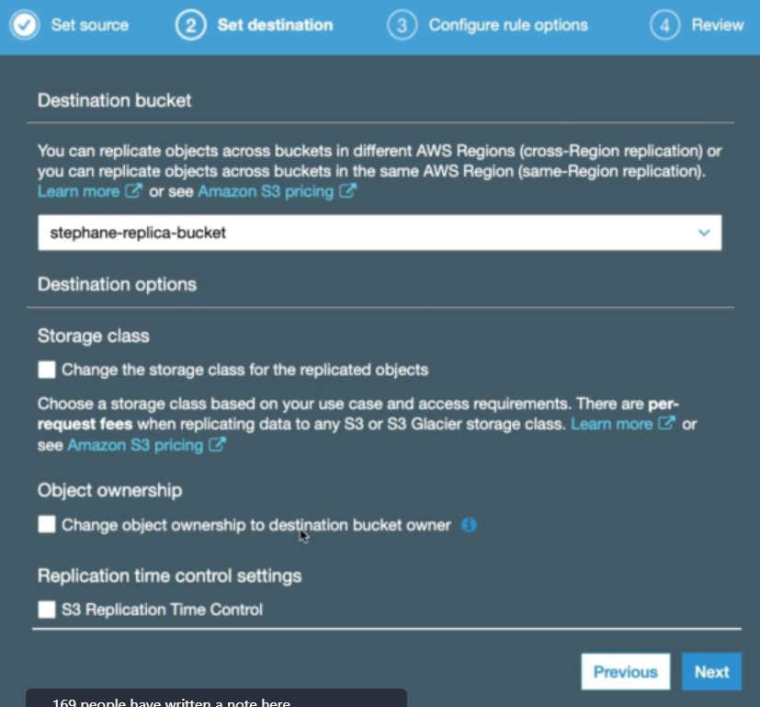

* Then, we can also change the storage class, ownerships etc as above.

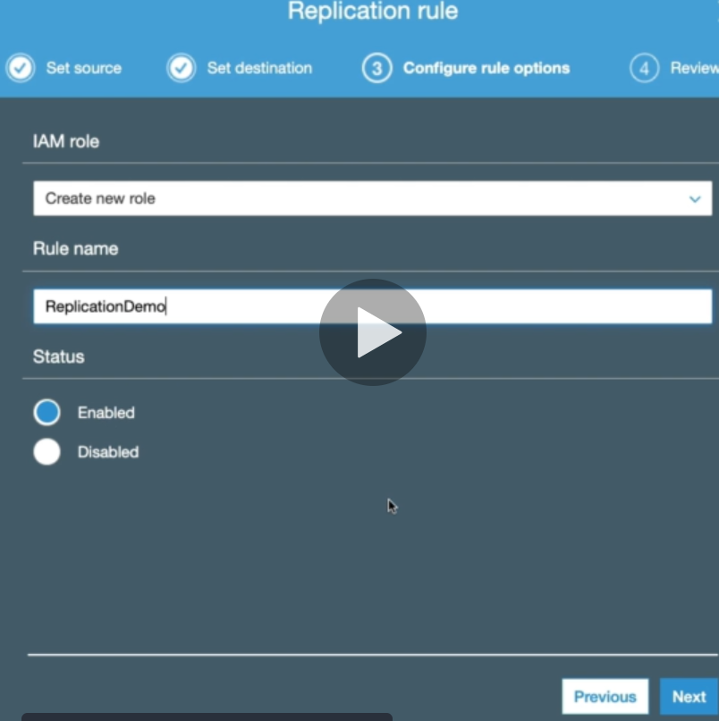

* Then we need to create a new role for the replication to happen. Finally, review it and save.
* Maybe we can select if the role is already there.

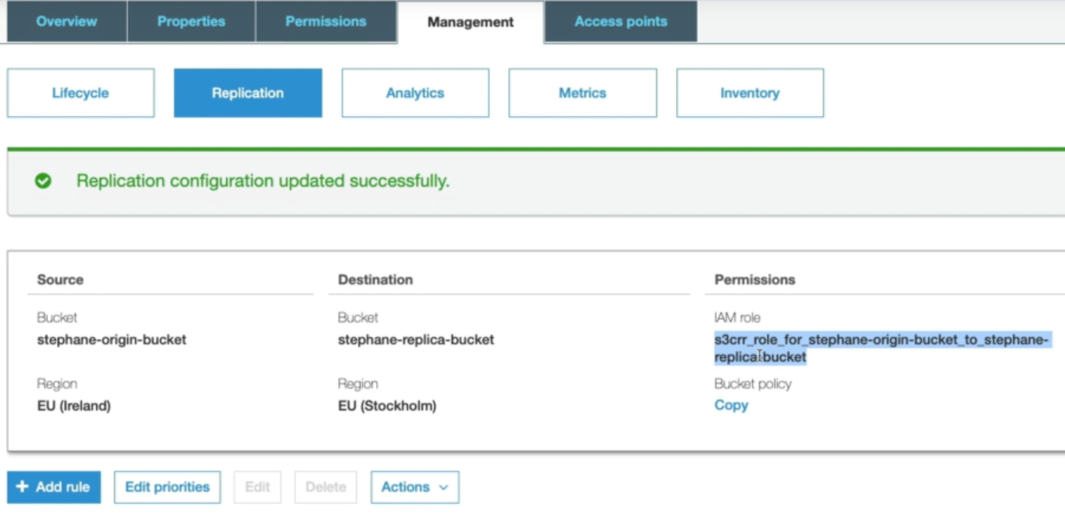

* Now, we can see that IAM role has been created and added to the bucket.

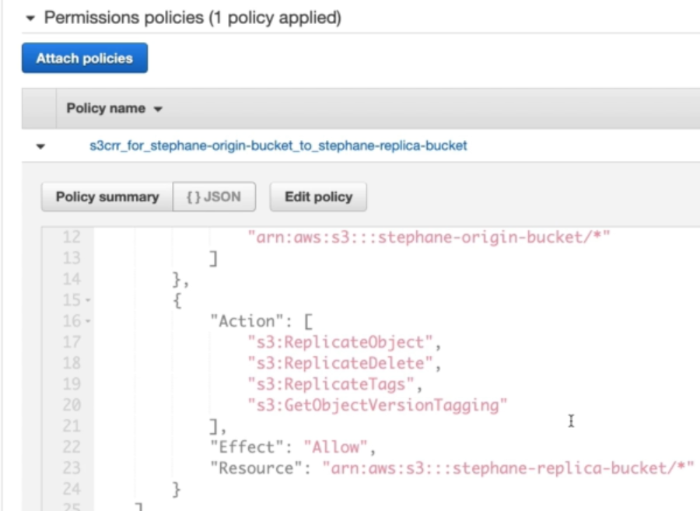

* We can see that IAM role got created with replication action between the buckets.
* After this, the current files of the bucket won’t be replicate to the other one. Only the new files which we upload after enabling the replication will only gets replicated on the other bucket.

**If any deletion on version or the source file, it won’t be replication on the other bucket**